**Benzie County Economic Development Action Plan**

**Findings and Objectives**

**By the Benzie County Task Force**

**October 1, 2014**

Table of Contents

Introduction 4

Purpose & Objective 4

Contractual Scope of Work 7

Methodology 8

Socio-Economic Conditions 10

Socio-Economic Overview 11

Benzie County Population & Trends 13

Population Tapestry 17

Wealth Concentration: Geographic and Age Considerations 21

Household Income 23

Benzie County Workforce 24

Farming 26

Land Use & Population Patterns 30

Population Shifts Within the County 31

Lowlands and Wetlands 33

Housing 34

Seasonal Home Ownership 36

Accessibility & Transit 36

SWOT ANALYSIS 38

Strengths 39

*Community Leadership* 40

*Natural beauty; resort lifestyle; tourist economy* 40

*High School Graduation Rates* 40

*Agri-Businesses* 40

*Population and Economic Hubs* 41

*Public Transportation within the County* 41

*Strong Retiree Base* 41

Weaknesses 42

*Seasonal Economy* 42

*Lack of Skilled Trades Training Opportunities* 42

*Workforce Readiness* 43

*Not a Major Destination* 43

*Limited Critial Infrastructure Systems* 44

*Disaggregated Value-Added Agricultural Efforts* 44

*Limited Manufacturing Base* 44

*Limited Promotion of Commercial & Industrial Opportunities* 45

Opportunities 45

*New Logistical Channels & Market Access* 45

*New Infrastructure Investment & Regulatory Reforms* 46

*Inter-County Busing* 47

*New Job Creation* 47

*Strong Senior Base Willing to Contribute* 47

*Changing Workplace Habits* 47

Threats 47

*Limited Public Perception* 48

*New Zoning Efforts* 48

*In-County Migration Patterns* 48

*Immigration & Seasonal Labor* 49

*Limited Industrial Parks and Sites* 49

Major Goals and Supporting Tactics as Developed by the Task Force 49

GOAL #1: BENZIE COUNTY WILL IMPROVE THE QUALITY, RELIABILITY AND CAPACITY OF ITS KEY INFRASTRUCTURE SYSTEMS SERVING IDENTIFIED GROWTH CORRIDORS, EMPLOYERS, AND COMMUNITIES DESIRING GROWTH. 50

GOAL #2: BENZIE COUNTY WILL FACILITATE SKILLED TRADES TRAINING AND OTHER PROGRAMS TO INCLUDE CO-OPS AND PARTNERSHIPS, OFFERED IN THE COUNTY WITH APPROPRIATE STAKEHOLDERS AND BUSINESSES. 51

GOAL #3: BENZIE COUNTY WILL ENCOURAGE THE GROWTH OF VALUE-ADDED AGRICULTURE AND AGRI-TOURISM AS A MEANS OF SUPPORTING SMALL FARMERS AND ENTREPREUNERS. 52

Conclusion 52

**Benzie County Economic Development Strategic Plan**

# Introduction

Over the course of 2014 the Traverse Bay Economic Development Corporation (TBEDC) has worked with the Benzie County Commissioners and its appointed Task Force to develop an Economic Development Strategic Plan for the County. TBEDC staff worked with the Task Force to facilitate the development of major economic development goals for the County, and to develop related tactics, or specific projects, necessary to achieve the plan’s objectives. The Task Force articulated three major goals to drive future prosperity:

1. Enhance critical infrastructure serving the county to accommodate long-term growth and prosperity;
2. Encourage skilled trades training for youth and the underemployed; and
3. Develop new opportunities related to value-added agriculture and agri-tourism, especially for the small farmer and entrepreneur.

This report is a compilation of findings and recommendations to date. It outlines the plan’s objectives and related scope of work, highlights specific socio-economic characteristics, identifies strengths and weaknesses, enumerates the Task Force’s major goals, and recommends tactics for achieving those goals.

# Purpose & Objective

The Traverse Bay Economic Development Corporation was engaged by the Benzie County Commissioners in November 2013 to facilitate the development of a Benzie County Economic Development Strategic Plan. The County Commissioners unanimously voted to enter into a contract with the TBEDC for this purpose. The name says it all, encapsulating specific guidance and a defined purpose from the County Commissioners:

Benzie County – the plan is to be uniquely Benzie County. The TBEDC was engaged to facilitate a plan that originated from the citizens of the County. Similarly, the plan’s findings need to be implementable by theCounty without outside assistance. It is not a generic, cookie-cutter approach, but specifically tailored to the needs and desires of the County.

Economic Development – the plan is to center around strategies to promote the economic development of the County. New jobs, an enhanced tax base, and compatible development represent the intended outcome. There is no dearth of existing plans and analysis for Benzie County, but this endeavor is to center around strategies specifically related to economic development.

Action Plan – the plan is organic and intended to be flexible in its implementation to match market requirements, county budget constraints, and opportunities as they arise. It is also designed to focus limited resources and time toward achievable objectives supported by measurable projects.

The original idea for an action plan was first articulated by County Commission Chair Don Tanner and Commissioner Roger Griner. In a May 2013 meeting with officials from the TBEDC, the Commissioners expressed a need and desire to articulate and focus a strategy to encourage economic development. It was noted that previous efforts to support job growth were more passive in nature, characterized by reflexive responses as opportunities arose. ChairTanner stated at the time, “our greatest export is our children.”

There was a general consensus that Benzie County is well positioned to continue as a tourist-based economy. Sleeping Bear Dunes, Crystal Mountain, Crystal Lake, blue ribbon trout streams, open fields and forestlands, and a general bucolic nature all underpin a tourist-based destination economy. At the same time, the Commissioners expressed a concern that Benzie County simply was not doing enough to promote a diversified economy capable of meeting the future needs of a younger generation. These concerns are amplified as new local zoning regulations are being explored that could have long term impacts on job creation, especially for future generations.

This was perhaps best highlighted when Frankfort-based Production Industries Inc. sought a new manufacturing facility in 2010 to accommodate new growth and expansion. Its plans to acquire property and construct a new building were thwarted by local government officials who were not supportive of the initiative. The company found it difficult to locate a suitable site within the County, and when it finally settled on a location, elected officials were unsupportive. In the ensuing years, little was accomplished by County leaders to identify and overcome the constraints to economic development.

Commissioners Tanner and Griner were focused on a much larger picture than simply site selection criteria to support new industrial development, however. Their vision for an actionplan encompassed many other considerations, including education, job expansion, quality of life, location advantages/constraints, transportation/supply chain, affordable housing, and critical infrastructure to support future growth. These considerations became the basis for further discussions that ultimately led to a scope of work designed to focus efforts with limited budgets for maximum long term effect. The ultimate goal: secure new job opportunities and prosperity for the citizens within the County, but with an emphasis on creating new opportunity for future generations, in a manner compatible with the County’s existing strengths.

# Contractual Scope of Work

A detailed scope of work was developed by TBEDC staff and ultimately, unanimously approved by the County Commissioners. The scope was broken into three distinct phases designed to focus efforts starting from “big picture” thinking about major goals; towards more detailed, supporting tactics; and ultimately to implementation strategies. While the County Commission remains the authority responsible for the plan, it commissioned an advisory group of local citizens to serve on a task force responsible for the plan’s development, facilitated by the TBEDC.

The scope of work was broken down as follows:

* Phase 1: Goals Identification

Work with the Benzie County Commissioners, supported by the Benzie County EDC and Chamber of Commerce, to facilitate the appointment of a Project Task Force comprised of key individuals from the County.

Work with the Benzie County Commissioners and Project Task Force to facilitate the identification and articulation of the County’s major economic development goals. The goals will define the overall direction and focus for County-wide economic development.

* Phase 2: Tactics Development

Identify, validate through research, and design tactical projects (tactics) to be implemented by the Benzie County Commissioners and County staff, or other identified stakeholders, to achieve the identified goals.

* Phase 3: Implementation Strategies

Identify and recommend implementation strategies to the Benzie County Commissioners, County staff, and other identified stakeholders related to the execution of Phase 2 tactics. The TBEDC is not to be the implementing agent but is to serve to facilitate implementation strategies by recommending approaches that use available resources within the County.

The parties further agreed to look for, and where possible secure additional funding, during Phase 3 activities, to further fund specific projects identified in Phase 2.

As a further component to Phase 3, the TBEDC agreed to develop a Strategic Plan matrix in Excel software designed to identify and track the goals and supporting tactics developed during Phase 3.

To date, all Phase 1 activities are complete. Phase 2 tactics and Phase 3 implementation strategies are provided in DRAFT form within this document. Phases 2 and 3 will be further refined and finalized with the Task Force in the coming weeks.

The cost of developing the Strategic Plan was $20,000. The TBEDC agreed to help fund this amount on behalf of the County in a number of ways. Along with the Benzie County Chamber of Commerce, it agreed to donate $5,000 to the project. Further, it agreed to assume the lead role in securing outside grants to defer the County’s costs. It applied for, and was subsequently awarded, a Rotary Charities planning grant in the amount of $5,000.

# Methodology

It remained important to all of the project’s stakeholders that the ultimate plan be the unique product of Benzie County. It was deemed critical that the plan originate from the citizens of Benzie County; and that it not be a cookie-cutter approach to economic development suitable for any other community. It needed to focus on the specific attributes, unique opportunities, and inherent challenges of the county. Similarly, the findings and recommendations were to come from the community, not from outside consultants with little knowledge and only a passing financial interest in the county. For this reason, a task force comprised of Benzie County citizens was empaneled by the County Commissioners to serve as an advisory board responsible for developing the plan. The TBEDC served as a facilitator to help the task force identify major goals and supporting tactics.

The following individuals serve on the task force:

* Don Tanner Benzie County Commission Chair
* Roger Griner Benzie County Commissioner
* Mary Carroll Benzie County Chamber of Commerce
* Troy Terwilliger Benzie County EDC and Graceland Fruit Company
* Peg Minster Benzie County Planning Commission Chair
* Tim Brian Smeltzer Fruit Company
* Chris MacInnes Crystal Mountain
* Mike Worden Honor Bank CEO
* Bob Boylan Expert Fulfillment
* Dave Micinski Benzie County Schools Superintendent
* Thor Goff Retired Business Executive and Entrepreneur
* Michelle Thompson Benzie County Treasurer
* Karl Sparks Benzie County Administrator
* Karen Roberts Owner, M&R Information Services, Inc.
* Randy Dye Remax

The Task Force has formally met on eight occasions. Each meeting was designed for a specific purpose as outlined below:

|  |  |  |  |
| --- | --- | --- | --- |
| **Meeting** | **Date** | **Purpose** | **Outcome** |
| Kick-Off Meeting | December 9, 2013 | Introduction & Issues Identification | Brainstormed a number of issues representing major goals for future economic development |
| Issue Identification | January 22, 2014 | Refining Major Goals | Identified three potential major goals to pursue |
| Goal Setting | February 19, 2014 | Setting Major Goals | Set three major economic development goals for the County |
| Major Issue | April 30, 2014 | Critical Infrastructure | Presentation and discussion by representative of Consumers Energy |
| Major Issue | May 21, 2014 | Value-Added Agriculture | Presentation and discussion by local small farmer |
| SWOT Analysis | July 29, 2014 | Develop a SWOT matrix | SWOT components included in draft document |
| Strategy Review | August 20, 2014 | Review and finalize recommended strategies | Approval of three major strategies for inclusion in report |
| Skilled Trades Training | September 3, 2014 | Review additional details related to skilled trades training | Adoption of, and inclusion of, mentor program in report |

Additionally, the Task Force facilitated a number of meetings related to skilled trades training:

* A team of educators and school administrators met with manufacturing executives on March 4, 2014 in a skilled trades summit designed to foster new ideas related to the provision of skilled trades training for the youth and underemployed in Benzie County.
* A follow-up meeting was held on May 19, 2014 at Northwest Michigan College’s Parsons Stulen Building, followed by a tour of Skilled Manufacturing Inc. in Traverse City. Participants of this meeting included Benzie County students interested in careers in the skilled trades. Educators, elected officials, and business owners also attended.
* The Task Force facilitated a conference in Benzie County, at Grow Benzie, on September 17, 2014. The conference was held in conjunction with Michigan Works. The County’s largest private sector employers met to discuss the challenges and opportunities related to skilled trades training; and they mapped out a broad strategy for marrying the educational and training needs of students to the human resource needs of county-based businesses.

During the course of the study period, TBEDC staff also interviewed a number of community business owners, elected and appointed officials. The goal of these discussions was to learn more about the opportunities and constraints unique to conducting business and growing prosperity in Benzie County. The full composite of these meetings, events, and discussions led the formulation of articulated economic development goals by the Task Force.

Preliminary findings were shared with the Benzie County Commissioners during its regularly scheduled March 18, 2014 meeting. The first two major economic development goals (enhance critical infrastructure and promote skilled trades training) were detailed to the Commissioners, and accepted. Other meetings occurred with Commissioners Tanner and Griner both before and during the contract period to establish direction and to seek guidance and input along the way.

To better understand the Task Force’s findings and recommendations, it is helpful to acknowledge the socio-economic conditions unique to the County, as well as its strengths and weaknesses as developed in a traditional SWOT (strengths, weaknesses, opportunities, and constraints) Analysis.

# Socio-Economic Conditions

A number of excellent studies about the Benzie County socio-economic condition were recently completed by a variety of different sources. There is no lack of pertinent data; and many of the findings and recommendations found in earlier analysis is very insightful. The following sources are among that impressive body of work:

* Benzie County 2013 Housing Strategy – an inventory and analysis of housing in the County prepared by the Northwest Michigan Council of Governments, with oversight from The Grand Vision Housing Solutions Network.
* Lakes to Land Regional Initiative – a detailed and comprehensive regional effort by the Alliance for Economic Success to coordinate master planning efforts through Manistee and Benzie Counties in a compendium of visually compelling documents.
* 2012 Economic Outlook – an economic forecast by the Traverse City Area Chamber of Commerce for the 5-county region, including Benzie County.
* Benzie County Recreational & Cultural Master Plan, 2009 – 2014 – the County’s recreation master plan.

Perhaps the most definitive analysis of the socio-economic conditions of Benzie County’s residents was written by Karen Roberts – a Task Force member – in her comprehensive 46-page report entitled “*Benzie County Comprehensive Plan, Update of Socio-Economic Trends*” and prepared for the Benzie County Planning Commission in September, 2007.

## Socio-Economic Overview[1]

A number of salient socio-economic indicators differentiate Benzie County from its adjacent counties.

* ***Benzie County has a small population base and low population density****.* Benzie County is relatively sparsely populated. Total County population in 2010 was 17,525. The estimate population in 2014 is 17,608; the lowest population when compared to the County’s four adjacent neighbors. Grand Traverse County had a population in 2010 of 89,986; Leelanau County was 21,708; Manistee County was 24,773; and Wexford County was 32,735.

Despite its relatively small geographic size, Benzie County had the second lowest population density among the five counties with 54.8 people per square mile. Manistee County had a lower population density at 45.6 people per square mile. By comparison, Wexford County (57.9 people per square mile), Leelanau County (62.5 people), and Grand Traverse County (187.3 people) had greater population densities.

* ***Benzie County represents a relatively small land area****.* In terms of total square land miles, Benzie County is the smallest county in the State of Michigan. The County has a total area of 860 square miles, of which 321 square miles (or 37%) is land and 538 square miles (or 62%) is water. There are 54 named lakes in Benzie County and numerous smaller ones; and the Lake Michigan shoreline runs for 25 miles along the County’s western edge. Benzie County has 205,440 acres of land. Forested areas cover 136,200 acres of the total land area, meaning that 66% of the total land area is forested. More than half of the County’s land mass is located within the designated boundaries of the Betsie River State Forest.
* ***Benzie County has a large 65+ aged population.***As of the 2010 US Census, Benzie County maintained the second highest percentage of 65+ aged residents among its immediate neighbors at 22.8%. Leelanau County was higher with 26.5% of its population aged 65+; while Manistee County (21.8%), Wexford County (23.4%), and Grand Traverse County (15.8%) all had smaller populations within this age bracket. Most of the County’s senior citizens reside in the western portion of the county, around Crystal Lake and in Frankfort. Interestingly, these areas are losing overall population while the townships along the County’s eastern edge are its fastest growing.
* ***Population fluctuations are the result of seasonality.*** The Benzie County Sherriff’s Office reports that the summertime population grows to roughly 43,000 people. This is a 146% increase over the year-round population base. The summertime swell in population has significant ramifications both in support of the local economy, but also as a drain on local resources.
* ***Seasonal home ownership is very high in Benzie County****.* Thirty-three percent of all housing in Benzie County is considered seasonal, as of the 2010 US Census. Seasonal home ownership is highest in Lake Township with 66% of all homes considered seasonal; followed by Crystal Lake Township (61%), Blaine Township (45%), and Benzonia Township (35%). All of these townships are located within the western side of the County, and all of them are dominated by frontage on Lake Michigan and/or Crystal Lake. Weldon Township also has a very high occurrence of seasonal home ownership at 56% -- most likely located within Crystal Mountain Ski Resort.
* ***Benzie County has relatively high educational attainment levels.*** As of the 2010 Census, more than 90% of Benzie County residents had graduated from high school. This compares to only an 88.7% high school graduation rate for the State of Michigan; and is higher than Manistee County (87.9%) and Wexford County (88%), but below the total number of residents with a high school diploma in Grand Traverse County (93.3%) and in Leelanau County (94.3%). At the same time, 24.1% of Benzie County residents possessed a bachelor degree; better than Wexford County (15.9%) and Manistee County (17.7%), but lower than Grand Traverse County (29.6%) and Leelanau County (39%).
* ***Benzie County has a very high home ownership rate.*** Almost 85% of Benzie County (84.6%) residents owned a home in the county in 2010. By comparison, this is very nearly the same rate as Leelanau County at 85.3%; and higher than all adjacent counties – Manistee County (79.4%), Wexford County (77.1%), and Grand Traverse County (76.7%). It is also higher than the State of Michigan home ownership average of 72.8%.
* ***Benzie County’s median home values represent the region’s average.*** The median home value in Benzie County is $155,700. Interestingly, it is close to the average median home values for the four counties surrounding Benzie County. Leelanau County ($237,100) and Grand Traverse County ($169,800) have higher median home valuations; while Wexford County ($105,200) and Manistee County ($113,100) are lower. The average median housing value of homes in Leelanau, Grand Traverse, Wexford, and Manistee is $156,300 – only $600 more than the median home value in Benzie County.
* ***Benzie County’s median home income represents the region’s average.*** Like median home values, Benzie County median home income levels are very nearly identical to the average of the four counties surrounding Benzie County. Benzie County median income in 2010 was $47,491. Median home incomes were higher in Leelanau County ($53,982) and in Grand Traverse County ($51,641), but lower in Wexford County ($40,660) and Manistee County ($41,228). The average of the median home income for these four counties is $46,878, only $613 less than the median home income of Benzie County.

## Benzie County Population & Trends

In her analysis, Roberts sites a number of significant differentiating trends related to County population characteristics. She notes:

While Benzie County’s population is growing rapidly, that growth is bifurcated. There are two distinct underlying dynamics behind population growth in Benzie County: one is the in-migration of retirees, primarily in the western parts of the County; the other is the in-migration of younger families in the eastern parts of the County, which are serving as bedroom communities for Traverse City. There is and continues to be a wide disparity in income and education within the County, raising questions about the County’s future to attract and sustain a prosperous economic base.

Since that analysis was complete, the population of Benzie County has leveled off in a significant manner. Benzie County has gone from the fastest growing population in the State of Michigan (driven by retirees and younger families, according to Roberts) to a net loss of population in 2012 and again in 2013. From 1970 to 1980 the County realized a 30.40% population growth; and in the decade from 1990 to 2000 a population growth of 31.13%. Combined growth for the years from 1970 to 2000 averaged 23.47%. However, the population shrank from 2010 to 2012 by -0.34%; and from 2012 to 2013 by -0.21%. As of Summer 2014, the population is estimated to be 17,608; representing a 1.03% increase from the previous year.

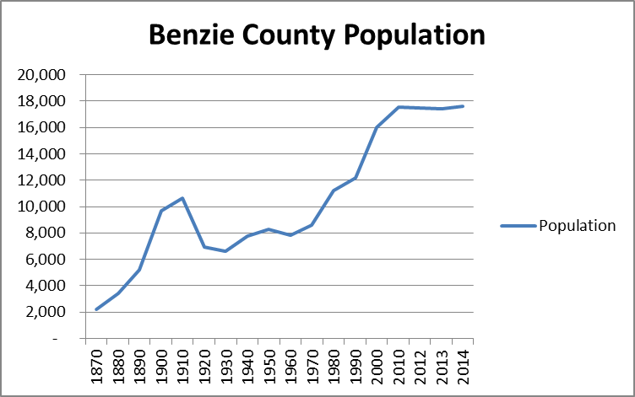

*Population increases have stabilized over the last three years with slight drops in 2012 and 2013. County-wide population in 2014 is projected to be 17,608 – a 1.03% increase over 2013.*

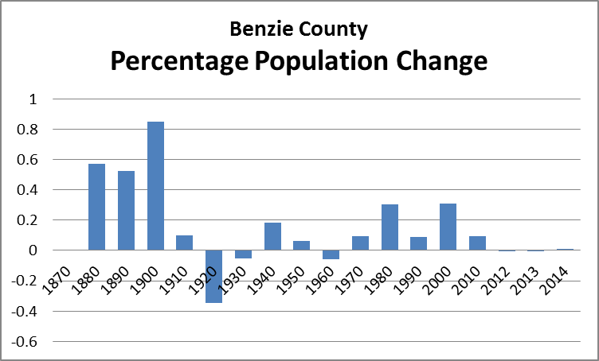

*The chart above shows the percentage of population change over time in Benzie County. The decades from the 1970s to the 1980s, and again from the 1990s to 2000s, saw 30+% growth; while the last three years have stabilized.*

The limited data available from 2011 to 2014 is not robust enough to establish a trend; but it clearly identifies that the County has lost population in recent years and is only projected to slightly grow this year. This finding is similar to a few other counties in Northern Lower Michigan who over the last four years also lost population. From April 1, 2010 to July 1, 2013 Benzie County lost -0.6% of its poplution; while Wexford County lost -0.3% and Manistee County lost -1.1%. This compares to a population growth in Grand Traverse County during the same period of 3.7%, in Leelanau County of 2%, and in the State of Michigan of 1%.

Since the 1970 US Census, however, overall population growth patterns appear fairly similar throughout the region, as measured by decennial census data. With the exception of Wexford County – which experienced a population decline from 1980 to 1990 – the counties adjacent to Benzie County experienced similar growth patterns. Overall growth was fairly consistent; so too was the rate of population growth as measured on a percentage basis of change. While overall population has increased for the region since the 1970s, the rates of growth have increased and decreased with similar patterns by county.



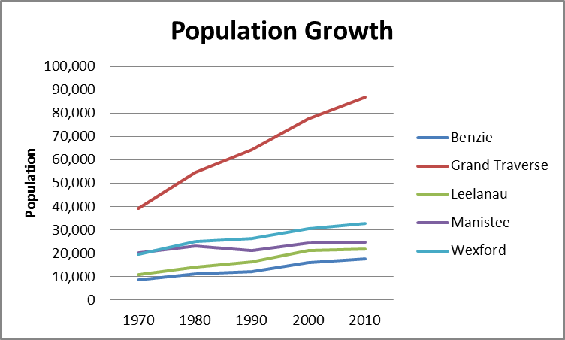



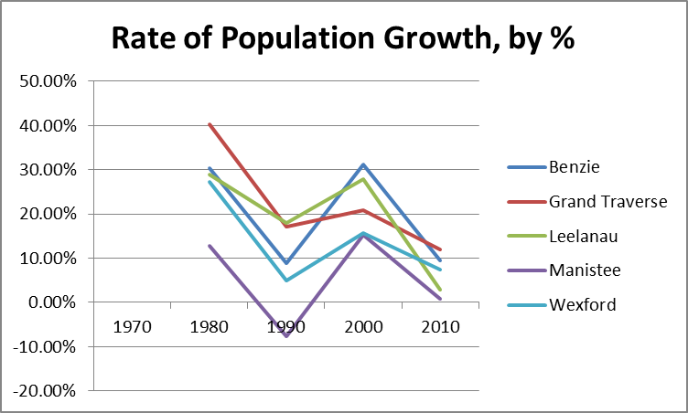

From 1990 to 2000, each of the counties adjacent to Benzie County experienced population growth; with Benzie County growing the most by over 30% (and approximately 10% faster than Grand Traverse County). The decade from 2000 to 2010 saw across the board declines in the rate of population increase for all Counties.

## Population Tapestry

While population growth has slowed in recent years, the current composition of Benzie County appears to reflect Roberts’ 2007 findings. The ESRI Dominant Tapestry Map (2014)[2] for the county reinforces the notion that younger families predominate in concentrated levels in the northeastern corner of the County, around Lake Ann; while seniors predominate in concentrated patterns along the County’s western edge, particularly in Frankfort eastward to include Beulah and the homes around Crystal Lake.

The area around Lake Ann (shown as light pink in the map below) is characterized as a “Family Landscape” and, more paricularly labeled by ESRI as “Middleburg.” These communities are described as follows:

Neighborhoods transformed from the easy pace of country living to semi-rural subdivisions in the last decade, when the housing boom reached out. Residents are conservative, family-oriented consumers. Still more country than rock and roll, they are thrifty but willing to carry some debt and are already investing in their futures. They rely on their smartphones and mobile devices to stay in touch and pride themselves on their expertise. They prefer to buy American and travel in the US. This market is younger but growing in size and assets.

They are further described as follows:

* [The community is characterized by] semi-rural locales within metropolitan areas.
* Neighborhoods changed rapidly in the previous decade with the addition of new single-family homes.
* Include a number of mobile homes.
* Affordable housing, median value of $158,000 with a low vacancy rate.
* Young couples, many with children; average household size is 2.73.

(<http://downloads.esri.com/esri_content_doc/dbl/us/tapestry/segment15.pdf>).

In contrast, the area around the Crystal Lake (shown in dark pink in the map above) is described as “Senior Styles,” and more particularly as “Silver and Gold” neighborhoods.

Almost the oldest senior market (second to The Elders), the difference of 10 years in median age reveals a socioeconomic difference: This is the most affluent senior market and is still growing. The affluence of Silver and Gold has afforded the opportunity to retire to sunnier climates that feature exclusive communities and vacation homes. These consumers have the free time, stamina, and resources to enjoy the good life.

* Residents of Silver and Gold prefer a more bucolic setting, but close to

metropolitan cities.

* Predominantly single-family, owner-occupied homes that have a median value

of $289,000.

* Neighborhoods include seasonal or vacation homes, reflected in the high

vacancy rate of 35%.

* Mostly older married couples with no children, average household size is 2.02

(<http://downloads.esri.com/esri_content_doc/dbl/us/tapestry/segment40.pdf>).

Similarly, the communities of Elberta and Frankfort (shown in yellow in the map above) are also characterized as predominantly “senior.” ESRI calls this group “Midlife Constants.”

Midlife Constants residents are seniors, at or approaching retirement, with below average labor force participation and above average net worth. Although located in predominantly metropolitan areas, they live outside the central cities, in smaller communities. Their lifestyle is more country than urban. They are generous, but not spendthrifts.

* Older homes (most built before 1980) found in the suburban periphery of smaller metropolitan markets.
* Primarily married couples, with a growing share of singles.
* Settled neighborhoods with slow rates of change and residents that have lived in the same house for years.
* Single-family homes, less than half still mortgaged, with a median home value of

$141,000.

(<http://downloads.esri.com/esri_content_doc/dbl/us/tapestry/segment20.pdf>).

The balance of the County (representing its vast majority by landmass) is characterized by ESRI as “Rustic Outpost” or “Cozy Country.” Rustic Outposts, further delineated as “Southern Satellites” (and shown on the map above as gray), is described as follows:

The second largest market found in rural settlements but within metropolitan areas located primarily in the South. This market is typically nondiverse, slightly older, settled married-couple families, who own their homes. Almost two-thirds of the homes are single-family structures; a third are mobile homes. Median household income and home value are below average. Workers are employed in a variety of industries, such as manufacturing, health care, retail trade, and construction, with higher proportions in mining and agriculture than the US. Residents enjoy country living, preferring outdoor activities and DIY home projects.

* About 79% of households are owned.
* Married couples with no children are the dominant household type, with a number of multigenerational households.
* Most are single-family homes (65%), with a number of mobile homes.
* Most housing units were built in 1970 or later.
* Most households own 1 or 2 vehicles, but owning 3+ vehicles is common.

(<http://downloads.esri.com/esri_content_doc/dbl/us/tapestry/segment46.pdf>).

Cozy Country communities, further described in Benzie County as “Rural Resort Dwellers” (and shown in the map above as green) are known for the following:

Although the Great Recession forced many owners of second homes to sell, Rural Resort Dwellers residents remain an active market, just a bit smaller. These communities are centered in resort areas, many in the Midwest, where the change in seasons supports a variety of outdoor activities. Retirement looms for many of these blue collar, older householders, but workers are postponing retirement or returning to work to maintain their current lifestyles. Workers are traveling further to maintain employment. They are passionate about their hobbies, like freshwater fishing and hunting, but otherwise have very simple tastes.

* Housing is owner-occupied, single-family homes, with some mobile homes. A strong market for second homes, these rural areas provide affordable homes valued at 8% less than the US median home value. Over half of the housing units are vacant due to a high seasonal vacancy rate.
* In this older market, 42% of households consist of married couples with no children at home, while another 28% are single person. Married couples with children at home have older school-age children.
* Set in scenic rural locations with proximity to outdoor activities, two vehicles are essential to get around.

(<http://downloads.esri.com/esri_content_doc/dbl/us/tapestry/segment25.pdf>).

## Wealth Concentration: Geographic and Age Considerations

The Benzie County tapestry, as descibed by ESRI, reinforces Roberts’ findings: suggesting a disparity of income and wealth between seniors and young families, concentrated in stronger poplulation centers, versus those residents opting for a more bucolic lifestyle in traditionally “country” settings. On a geographical basis, wealth in Benzie County is clearly concentrated in Frankfort, Elberta, and around Crystal Lake (including Beulah and Benzonia) and Lake Ann.

Not surprisingly, wealth in the County is further concentrated among the elderly; which makes up nearly half of the County’s overall population. The population between the ages of 15 and 54 accounts for 51.6% of the total; while the population above age 54 equates to 48.4% of the total. Nearly half of the County’s population is at, or nearing, the age of retirement. The US Census Bureau predicts that the elderly population, age 50+, will increase through 2019 by slightly over 1%; while the percent of households comprised of people age 55+ will increase 1.3%.

|  |  |  |  |  |  |
| --- | --- | --- | --- | --- | --- |
| **Demographic** | **2010** | **2014** | **2019** | **2014 – 2019 Change** | **2014 – 2019 Annual Rate** |
| Total Population | 17,525 | 17,608 | 17,837 | 229 | 0.26% |
| Population 50+ | 7,659 | 8,264 | 8,706 | 442 | 1.05% |
| % Households 55+ | 52.1% | 55.5% | 59.2% | 3.7 | 1.30% |
| Median Household Income 55+ | --- | $39,611 | $48,063 | $8,542 | 3.94% |

Average and median net worth is highest among the elderly population. This is not surprising given the additional years of work and investing to accumulate net worth, of course.



It is revealing, however, that the age groups between the <25 to 54 year old brackets maintain a higher net worth than the 55+ brackets in net worth up to $99,999; while the group 55+ maintains a considerably higher net worth from $100,000+.

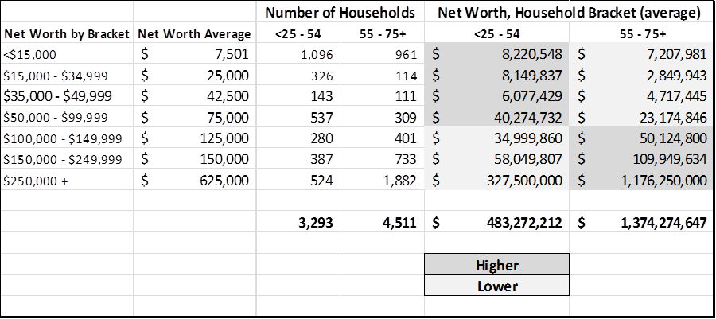

The age groups between <25 to 54 maintain an almost $25 million higher aggregate net worth than the age groups 55+; while the 55+ age group maintains a significantly higher combined net worth of $1.3 billion than the <25 to 54 age groups.

As described by ESRI, this disproportianate wealth, concentrated in the elderly, is located primarily in the areas around Crystal Lake, Lake Ann, and the Village of Frankfurt. Less wealthy populations, primarily younger or working class families, tend to be located in more remote areas of the County.

## Household Income

The median household income in Benzie County is $47,491. This is higher than Manistee County at $41,228 and Wexford County at $40,660, but lower than Leelanau County at $53,982 and Grand Traverse County at $51,641. By further comparison, the median income for the State of Michigan is $48,471. The average income for Benzie County is $58,128.

|  |  |  |  |  |
| --- | --- | --- | --- | --- |
| **2014 INCOME** | **NUMBER** | **PERCENT** | **2019 FORECAST** | **PERCENT CHANGE** |
| <15,000 | 933 | 12.6% | 11.6% | -1.00% |
| $15,000 - $24,999 | 869 | 11.7% | 8.5% | -3.20% |
| $25,000 - $34,999 | 879 | 11.9% | 10.2% | -1.70% |
| $35,000 - $49,999 | 1,261 | 17.0% | 14.9% | -2.10% |
| $50,000 - $74,999 | 1,821 | 24.6% | 25.6% | 1.00% |
| $75,000 - $99,999 | 911 | 12.6% | 15.8% | 3.20% |
| $100,000 - $149,999 | 435 | 5.9% | 8.5% | 2.60% |
| $150,000 - $199,999 | 159 | 2.1% | 2.8% | 0.70% |
| $200,000+ | 120 | 1.6% | 2.1% | 0.50% |

Research by ESRI indicates that in the last year there were 802 families in Benzie County living below the poverty line. This represents 10% of all households in the County.

## Benzie County Workforce

The Benzie County workforce is comprised primarily of private sector workers in the retail, services, and construction industries. Retail trade represents 13.9% of the overall business establishments in the county, employing 16.6% of all workers. The service sector (including hotels and lodging with 2.8% of all establishments and 11.7% of total workforce) includes 41.7% of all businesses, employing 43.6% of all workers. Construction represents 14.8% of all businesses and employs 8.2% of the overall workforce. Government employees represent 8.5% of all the County’s workers.

Manufacturing is not inconsequential, but does represent fewer businesses and jobs than retail, services, and construction. There are 53 manufacturing businesses in the County representing 3.4% of all businesses, employing 517 people or 7.8% of the total workforce. Total manufacturing employment is about half of total retail jobs, and about 18% of total service jobs. Magna Interior Trims, which employs about 240 people, recently announced plans to add 100 more positions. The relative strength (or weakness) of the manufacturing sector is significant in light of the community’s stated objective to faciliate additional skilled trades training in the County. Presumably, graduates from any skilled trades training program need a suitable manufacturing job, preferably within the County.

Agriculture and Mining represents 5.9% of all business establishments in the County, employing 3.1% of the total workforce. These numbers do not reflect the agricultural-related contributions of Graceland Fruit and Smeltzer Fruit, both with about 100 to 300 employees each. These larger agri-businesses are captured as wholesale trade establishments. When combined with Agriculture and Mining, however, these companies aggregate to represent more than 6% of the County’s total employment; a couple of percentage points below costruction and government. This is significant because the community has established the growth of smaller entrepreuner, value-added agricultural businesses as a key objective.



# Farming

Agriculture and mining estalbishments represent 5.9% of all businesses in Benzie County, which equates to 3.1% of the County’s total jobs. As noted, the inclusion of Smeltzer Fruit and Graceland Fruit operations bump the total agricultural-related jobs to just over 6% of the total.

While the Task Force has identified value-added agricultural opportunities as a key economic development objective, it is noteworthy that the Benzie County farm scene contracted between 2007 and 2012. According to the US Farm Bureau’s 2012 Census of Farms, the number of farms shrunk during that period from 205 to 181, a 12% reduction; the total acreage dropped from 21,069 to 20,646, a 2% reduction; and the total market value of products sold was reduced from $7,981,000 to $6,396,000, a 20% reduction. The average reduction in the total value of products sold, per farm, was 9%. The good news is that the average size of farms in Benzie County increased during that period by 11%, from 103 acres to 114 acres.



Of Michigan’s 83 counties, Benzie County ranks 68th in the total value of all agricultural products sold; having sold $6,386,000 in 2012. It is 67th in the value of all crops sold ($3,320,000) and 63rd in the value of all livestock, poultry and related products sold ($3,077,000). Relative to other counties in the State, Benzie County ranks low in these categories. Compared to other counties, it is not a significant competitor relative to the total market value of agricultural products sold in the State of Michigan.





Benzie County farmers are most competitive, as a comparative rank of state-wide totals, in the production value of honey bees sold or leased (ranked 2nd), tart cherries sold (ranked 6th with $1,795,000), apples sold (ranked 11th with $821,000), and fruits, nuts, and berries sold (ranked 15th with $1,967,00). Farmers of these products are well established, and these categories therefore represent logical commodities for future growth. They also represent strong contenders for value-added products. For example, the County’s strong position in honey bee production tracks with the County’s growth in mead production and related agri-tourism.

Of all of the commodities measured, the fruit, nuts, and berries category is the highest value, representing 31% of the total. This is followed by cattle and calves at 23% of the total. There are best-in-class examples throughout Northern Michigan related to value added opportunities using fruit and berries. For example, Cherry Republic and American Spoon have established strong positions in the marketplace by processing these commodities into finished goods and marketing their strong brands on a national basis. Given the County’s strong position in cattle and calves, there might likewise be an opportunity for value add in this category; for example, butchery and charcuterie. It is worth noting that fruit and berry production, and cattle and calf production, both occur on only 9% of all farm acreage in the County. Given the County’s strong position in these commodities, there may be an opportunity to increase the total acreage in production to support increasing sales.

It is a common refrain throughout Northern Michigan, and across our country, that farmers are aging. This is certainly the case in Benzie County, where the average age of its farmers is 60.9 years. Fifty-two percent of these farmers claim farming as their principal occupation.



Sixty-nine percent of all of Benzie County farms realize total annual sales of less than $10,000; 22% earn between $10,000 and $100,000; and 15% earn more than $100,000.



Somewhere between 15% to 24% of all Benzie County farms generate less annual revenue than the federal poverty threshold of $15,510 (for a family of two). As noted, however, 52% of the County’s farmers claim farming as their principal occupation. It is inferred that additional income, either from other business or invested income, a part-time job, or a contributing spouse, is the norm to keep these family farming operations afloat.

Total farm production expenses, taken for the County as a whole, were $8,962,000 in 2012; making the average per farm expense for that year $49,512. The result: net cash from farm income for all the County’s farmers was -$207,000; or -$1,142 per farm. Statistically, farming is a tough operation in Benzie County.

# Land Use & Population Patterns

It is important to note that much of Benzie County is undevelopable due to the existence of vast swaths of public land. Those areas characterized by ESRI as Cozy Country and Rustic Outposts tend to coincide with much of the Betsie River State Forest. In fact, the Betsie River State Game Refuge, Sleeping Bear Dunes National Lakeshore, and Betsie River State Forest combine to represent much of Benzie County – at once making it a magnet for outdoor enthusiasts while at the same time constraining new commercial and industrial development. The following townships are uniquely constrained in this manner: Lake, Platte, Inland, Colfax, Weldon, and the southern portion of Almira, as demonstrated by the “Current Taxable Value” map provided by the Benzie County Equalization Office.

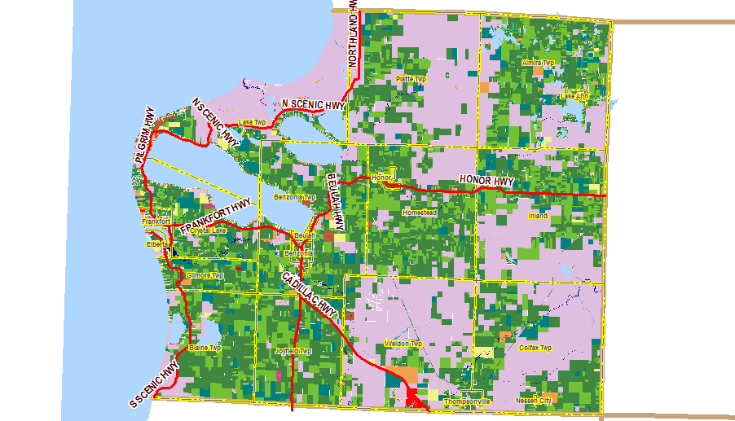

The Equalization Office map shows those areas of the County (in light purple) with zero taxable value. These are National, State, or locally owned public parcels that are not taxable and, therefore, both generate no public sector revenues and remain unavailable for development. These areas tend to be furthest east of major population concentrations like Frankfort, Beulah, and Benzonia; except for Lake Township which is immediately to the north of Crystal Lake and largely defined by the Sleeping Bear Dunes National Lakeshore.

## Population Shifts Within the County

Oddly, these are also the areas of the County experiencing the greatest population growth. As Roberts’ describes in her 2007 study:

The second trend is the population move out of the villages and City of Frankfort. One of the central features of the 1995 Master Plan was that open spaces be preserved and that the pattern of sprawl development be minimized. The actual trend is in the opposite direction. The [share of county population living in one of the five villages or City of Frankfort has declined markedly over the 1960 – 2005 period from nearly half the county population in 1960 to just over one-fifth in 2005. In fact, only Lake Anne and Thompsonville experienced noticeable growth in absolute numbers, and Beulah, Elberta, and Frankfurt actually lost population.

This trend continued through the 2010 census with the fastest population growth experienced in the eastern half of the County; while Lake Township also experienced significant population growth.



**BENZIE COUNTY POPULATION SHIFTS, 2000 - 2010**

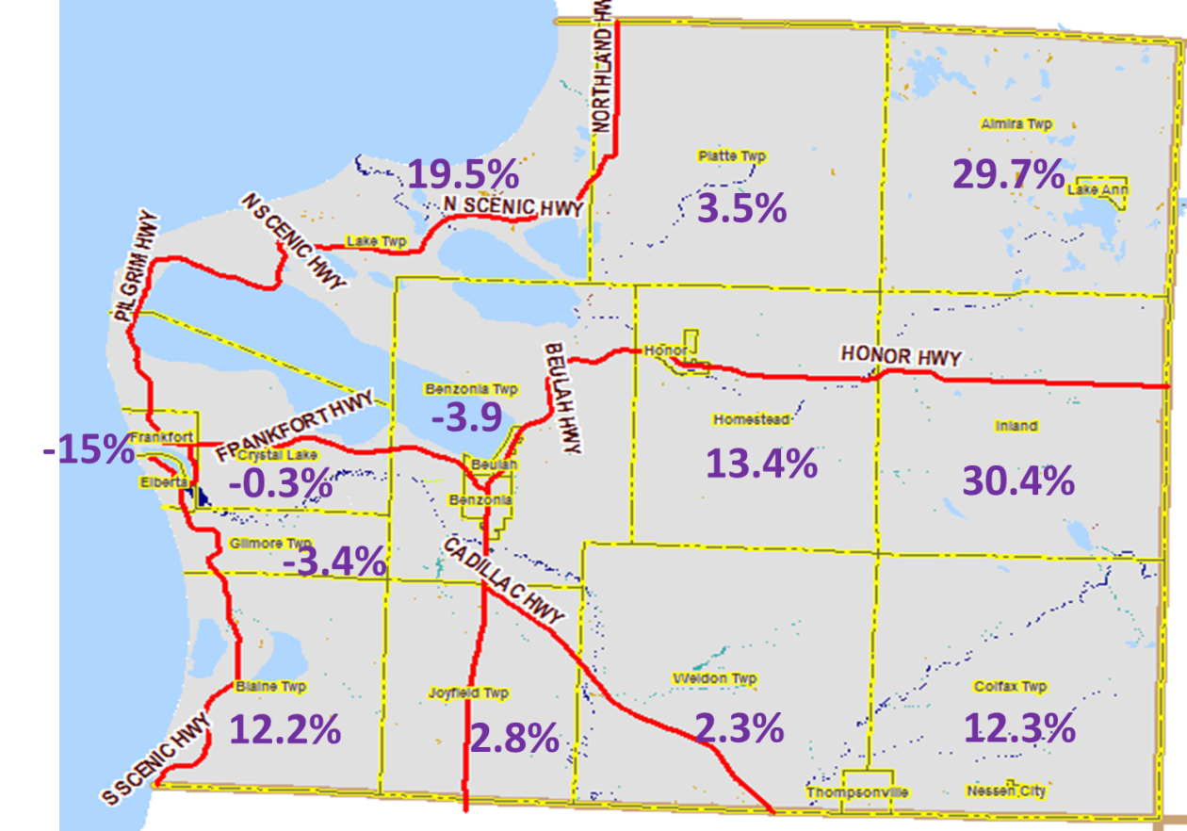

Almira and Inland Townships, both on the eastern edge of the County, and both with significant portions of publicly held land, experienced the fastest population growth at approximately 30% increases. Lake, Homestead, Colfax, and Blaine Townships experienced population gains between 12% - 19.5%. Platte, Weldon, and Joyfield Townships experienced slight growth between 2.3% - 3.5%. As Roberts noted in her study, Frankfort, Crystal Lake, Gilmore, and Benzonia (including Beulah) experienced declines. There is a significant population shift within the County with residents opting to live away from its traditional, more developed population centers.

## Lowlands and Wetlands

Land use in Benzie County is further constrained by a large amount of lowlands and wetlands. The Lakes to Land Initiative reports slightly more than 22,762 acres of lowlands and wetlands within the county. Shown in the map below (from the Lakes to Land Initiative) in green shading, these areas are not conducive to new development.



The areas within the County thought to be the least desirable for future growth are the fastest growing; while the areas around traditional population centers are experiencing continued population decline.

## Housing

Despite dropping from a year 2000 high of 85.7%, Benzie County maintains a very high percentage of home ownership. In 2012, 84.6% of all housing units were owned in fee simple. This is slightly below Leelanau County at 85.3%; but higher than Manistee County at 79.4%, Wexford County at 77.1%, and Grand Traverse County at 76.7%. It compares to the State of Michigan at 72.8%.

In 2014, there are 12,193 housing units in Benzie County with a median home value of $155,700 and an average value of $200,367. Interestingly, the County median home value is close to the average median home values for the four counties surrounding Benzie County. Leelanau County ($237,100) and Grand Traverse County ($169,800) have higher median home valuations; while Wexford County ($105,200) and Manistee County ($113,100) are lower. The average median housing value of homes in Leelanau, Grand Traverse, Wexford, and Manistee is $156,300 – only $600 more than the median home value in Benzie County.

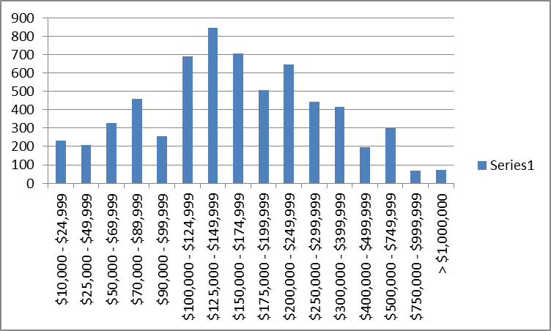

## Seasonal Home Ownership

It is additionally noteworthy that all of the jurisdictions (townships, villages, and Frankfort City) 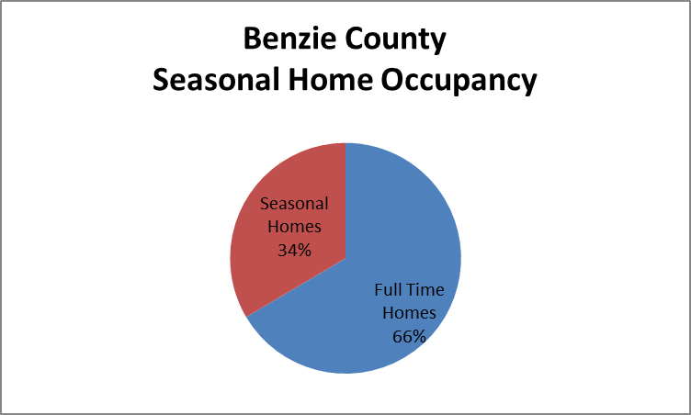experienced an increase in the number of housing units between 2000 and 2010. It is likely that the increase in housing units throughout Benzie County, but especially where population fell, may be attributed to seasonal homes. This would indicate an increasing trend for seasonal homes likely occupied by part-time residents, probably representative of Benzie County’s growing retiree base.

Thirty-three percent of all housing stock in Benzie County is represented by seasonal homes. The highest concentration of seasonal homes is found in Lake Township (66%). Other townships with more than 50% seasonal homes include Crystal Lake (61%) and Weldon (56%). Inland Township has the lowest amount of seasonal homes at 9%. The seasonal nature of the Benzie County economy is no surprise to its residents. As represented by the large abundance of seasonal housing stock, the local economy is largely influenced by part-time residents. Anecdotally, it is reported by residents that the seasonal population is largely comprised of seniors and retiress who spend the summer months in the county. The seasonal nature of the local economy is both advantageous and a challenge. At once it represents a large body of experienced seniors with disposable income and time to contribute – if properly channeled; while also creating a fluctuating, seasonal dynamic with part-time residents incapable of fully supporting a growing economy and local schools.

## Accessibility & Transit

Benzie County offers limited accessability. It has no rail or commercial aviation service. It’s highway system is similarly limited.

US-31 is the predominant state highway in Benzie County. It provides north – south access from Manistee to Benzonia Township, where it turns eastward to Grand Traverse County. While US-31 carries the bulk of Benzie County’s vehicular traffic, it only directly serves the townships of Joyfield, Benzonia, Homestead, and Inland. From Honor, in Homestead Township, through Inland Township to the Benzie County/Grand Traverse County line, the road serves more than 10,000 vehicles daily (as reported by the Lakes to Land Initiative); the busiest roadway and road section in all of Benzie County.

M-22 is also a state highway, but at only 116 miles long it provides a scenic route of Benzie County’s lake frontage along the county’s western edge following the Lake Michigan shorelline. M-22 is designated as part of the Leelanau Scenic Heritage Route and, as such, cannot support commercial or industrial development.

M-115 is the County’s only other state highway. It cuts diagnolly from southeast to northwest across Weldon Township to US-31 in Joyfield Township. It serves 2,500 – 10,000 vehicles daily and from Benzonia to Franfort it is improved with a paved shoulder.

The intersection between US-31 (north – south) and M-115 (east-west) in Benzonia Township represents the epicenter of the County’s commercial roadway system. The Township serves as the County’s governmental seat and, together with the City of Frankfort, represents the hub of commerce. This is an important intersection with nearly 20,000 cars intersecting it on a daily basis.

The Benzie County Road Commission reports that the vast majority of Benzie County roads and bridges are seasonally weight restricted or closed year round to vehicles exceeding 25 tons in weight. Class “A” roads, capable of supporting commercial and industrial development, are limited.

|  |  |
| --- | --- |
| **Benzie County All-Season “Class A” Roads** | |
| River Road (CR 608) | From US-31 to M-22 |
| CR 669 | From Thompsonville north to Leelanau County |
| Joyfield Road | From US-31 to Smeltzer Road |
| CR 602 | From US-31 east to Kurick Road |
| Cinder Road (CR 608) | From CR 677 to CR 669 |
| Indian Hill Road | From US-31 north to Fowler Road |
| Fowler Road | From Indian Hill to M-22 |
| Grace Road (CR 606) | From US-31 west to M-22 |
| Platte Road (CR 706) | From US-31 to M-22 |

The County’s limited State highway system, together with weight restricted roads and bridges, conspire to limit future commercial and industrial growth within the County.

# SWOT ANALYSIS

A SWOT Analysis is an excellent tool to assess a County’s potential. It provides an unbiased view of the strengths, weaknesses, opportunities, and threats faced by a community. It is used here as a critical component to the Economic Development Strategic Plan to identify what is working well and what is not within the County. It informs the work and analysis by the Task Force, particularly related to defining major economic development objectives, by providing an important base of thought to leverage existing strengths and mitigate potential weaknesses.

The chart below highlights the SWOT Analysis for Benzie County. Further details are provided in the written commentary that follows.

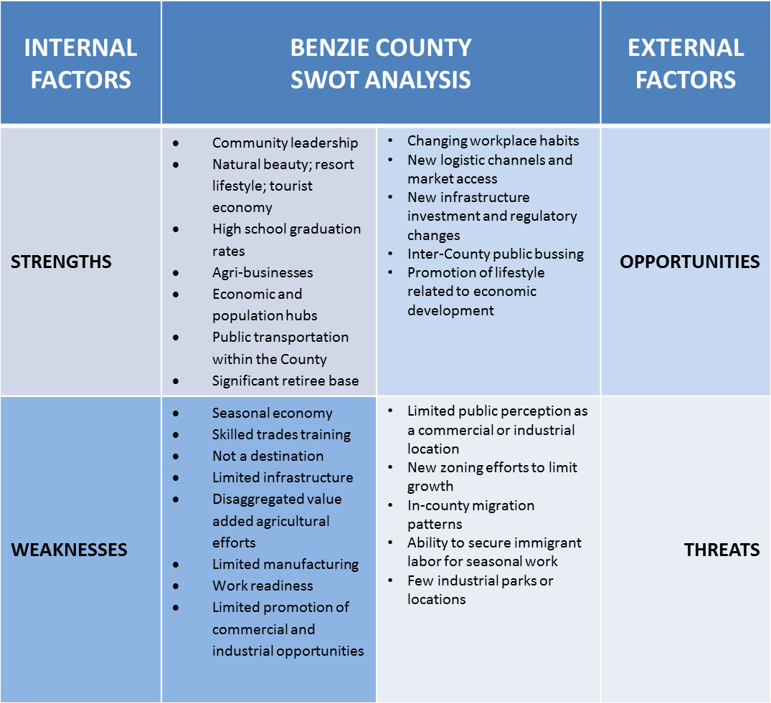

## Strengths

Benzie County has a number of strategic advantages that form a series of core strengths from which to build a robust economic development strategic plan.

* Community leadership
* Natural beauty; resort lifestyle; tourist economy
* High school graduation rates
* Agri-businesses
* Economic and population hubs
* Public transportation within the County
* Significant retiree base

### *Community Leadership*

Benzie County’s elected leaders are strong advocates for the development of an economic action plan to help define a path towards additional prosperity. They are largely unified in the need to take concrete, definable steps to promote economic development with a common goal of creating new opportunties for its next generation. This unity of purpose and clarity of vision form a critical strength. As one County Commissioner said, “Our greatest export is our children.”

### *Natural beauty; resort lifestyle; tourist economy*

Those children grow up in Benzie County with a distinct attachment to the land, the lakes, and its people. The County’s aesthetic beauty and laid-back lifestyle make it a special place differentiated from the hustle and bustle of big city life. This difference forms the basis for the development of resort amenties and attractions that undergird a strong tourism economy. Sleepy Bear National Dunes, for example, is an unheralded destination unique the world-over to Benzie and Leelanau Counties. Crystal Mountain represents a true four-seasons destination that cannot be easily replicated. The County’s natural beauty and the tourism economy that is inherent to it are definitive strenths.

### *High School Graduation Rates*

Benzie County has strong schools with excellent graduation rates. The County has two school districts: Benzie County Central Schools and Frankfort-Elberta Area Schools. Benzie County Central includes Betsie Valley, Crystal Lake, Lake Ann, and Platte River Elementaries; Benzie Central Middle School; and Benzie Central High School. The district served 1,839 students in 2011. Frankfort-Elberta Area Schools include Frankfort Elementary School, and the Junior and Senior High School. The district has a student population of 508 students in 2013. During the 2010-2011 school year, the Benzie Central graduation rate was 97.32%; and in 2012 the Frankfort-Elberta District’s graduation rate was 91.67%. By comparison, the 2012 graduation rate at West Senior High School in Grand Traverse County was 91.12%; and the rate at Central High School was 90.19%. Taken as a whole, 90.3% of Benzie County residents graduated from high school.

### *Agri-Businesses*

The County has a bugeoning small agricultural base that is adopting value-added practices. Wineries, meadearies, food producers, and flower growers are beginning to find their niche in the value-added farm markets of Northern Michigan. While still a very small percentage of the overall economic base, these value-added farmers and entrepreuners are finding additional value in final goods processing. Many are accessing the assistance of regional organizations like the Food and Farm Network, Grand Traverse Land Conservancy, and Taste the Local Difference. These organizations have established a goal of producing 20% of the region’s food from local sources by 2020.

### *Population and Economic Hubs*

Benzie County also has well-developed population centers and economic hubs. The City of Frankfort, and villages of Beulah, Benzonia, Lake Ann, and Honor are all distinct communities that form well-defined population centers and hubs of commerce. They are served by public transportation. Each community establishes its own unique sense of place. In 2012, these communities represented 16% of the County’s total population. They serve as governmental seats, places of commerce, and recreation destinations. While some are constrained by infrastructure capacity, they all could support additional in-fill development.

### *Public Transportation within the County*

Benzie County has an excellent public transit system that was developed in 2005, in part, to support economic growth. As described by the Benzie County Transit Authority:

One of the Initiative’s goals was to help the county’s economic growth. Public transportation not only takes workers to their workplace, but a public bus connects residents, visitors and consumers to local businesses and other places of recreation which is vital to the area economy. The Benzie Bus Initiative also knew that affordable and consistent transportation would improve educational opportunities in both schools and workplace. Creating this link gives more people access to job training, increased educational and employment opportunities, and social service programs.

As of 2013, Benzie Bus employed over 40 people and maintained a first-class fleet of 22 vehicles. The Authority provided over 89,000 rides; which averaged more than five rides per year for every man, woman, and child in Benzie County. Within the last three years, Benzie Bus purchased a strategically located nine-acre parcel of property along M-31 and constructed a new 6-bay maintenance garage – a compliment to its 13,000 square foot office and storage building. Benzie Bus has added fuel efficient and clean burning vehicles to its fleet. Voters embraced these initiatives by re-approving the Authority’s .05 mil request by a margin of 3 to 1.

### *Strong Retiree Base*

Benzie County has a significant retiree base capable of volunteering their time, talents, and treasure to community and philanthropic endeavours. Retirees bring a lifetime of experience to bear on the community’s challenges. Their “thought leadership” can make the difference between failure and success. Nearly half of Benzie County’s population base is comprised of people aged 50+. Thirty-four percent of all homes in the county are second homes. The seasonal poplution increases dramatically each summer by seniors reestablishing themselves in summer homes and cottages. This is a demographic with time and experience to commit to the community.

## Weaknesses

It is good policy to recognize those areas that should be addressed to mitigate inherent weaknesses to new growth. Benzie County has unique issues that require attention. Most of these relate to specific areas identified by the Task Force as major objectives to facilitate economic development. For all its strengths, Benzie County labors with inherent structural constraints that impede new growth, development, and prosperity.

* Seasonal economy
* Lack of skilled trades training opportunities
* Not a major destination
* Limited infrastructure
* Disaggregated value-added agricultural efforts
* Limited manufacturing
* Work readiness
* Limited promotion of commercial and industrial opportunities

### *Seasonal Economy*

Seasonality is a major influence on the Benzie County economy. The Benzie County Sheriffs Office reports that the summertime population grows to roughly 43,000 people, a 146% increase over the year-round population. Thirty-four percent of the County’s housing stock is represented by seasonal homes. Nearly 50% of the full-time population is 50+ years in age. The lakes and rivers, bucolic setting, and resort-style amenities point to a local economy strongly driven by an aging, seasonal demographic largely motivated by summertime cottages and small-town charm in a natural setting.

While this is a significant driver to the local economy, it also represents challenges: a fluctuating population base is unsteady; it can create an economic dependency; and requires a certain level of heightened resources during intense periods. Service and retail businesses tend to prosper during the summer months, while the winter season leads to a slowdown. It is an economy charaterized by feast or famine. The situation adds extra urgency for an economic development strategic plan that is focused on long term goals, and that can weather the inherent changes brought by seasonality.

### *Lack of Skilled Trades Training Opportunities*

Benzie County offers few alternatives to a four-year college education for graduating seniors and the underemployed. As the Task Force has acknowledged: facilitating skilled trades training opportunies for the young and underemployed is a number-one priority. Most of the Task Force’s members acknowledged a strong desire to create local training opportunities as a means of thwarting the emigration of young people from the County. While the Intermediate School District, and Northwestern Michigan College, both in Grand Traverse County, offer training opportunties, they remain relatively remote and distant from Benzie County’s population concentrations. The drive from Frankfort or Benzonia, for example, could become tedious on a daily basis. They are not convenient.

The Task Force repeatedly expressed concerns that young people and the underemployed in the County have few post-high school opportunties to a four-year college degree. The population of Benzie County possessing a Bachelors degree is relatively low when compared to surrounding counties. Twenty-four percent of the County’s population has earned a Bachelors degree. This is lower than the State average at 25.5%; Leelanau County at 39%; and Grand Traverse County at 26.6%. Manistee (17.7%) and Wexford (15.9%) Counties are lower. There is a strong consensus among the Task Force that middle school and high school students are generally steered towards a four year college experience without the benefits of being exposed to alternatives, like a skilled training program. This leaves those students with few alternatives in the event they choose not to pursue a four-year college education.

### *Workforce Readiness*

Benzie County is constrained by a host of labor-related issues. These are difficult to quantify, and certainly not unique to Benzie County; yet they represent real challenges. It is anecdotally reported by business owners that the unemployed and underemployed in the County often lack foundational employment skills. Many are not prepared for the workplace. It is reported that skilled labor, capable of executing work-related tasks, or learning them, is difficult to find. Basic skills tests and drug tests are routinley failed by those seeking employment. For those that qualify for new jobs, the lack of affordable housing is a real problem. It is commonly reported that the current available housing stock in the County is inadequate or too expensive. New jobs, like the expanding opportunites at Magna International, are often filled by commuters from Grand Traverse and Wexford Counties.

### *Not a Major Destination*

Benzie County is off the beaten path and not easily accessible. Situated along Lake Michigan, behind imposing sand dunes and edged by vast forestlands, the County is an island not conveniently accessed by north-south vehicular traffic destined to large population centers or hubs of commerce in Southern Michigan. Traffic from Traverse City to Grand Rapids, for example, generally follows the north – south route along US-131, completely bypassing Benzie County. Motorists heading to Benzie County do so with a specific destination in mind, but the flow of major traffic does not intersect the County. This constrains the efficient transportation of goods and resources. Similarly, the County is not currently served by commercial air or waterborne shipping.

### *Limited Critial Infrastructure Systems*

Benzie County is severely limited in its foundational infrastructure systems. Gas, electric, municipal water and sewer systems, and broadband are all limited; and pose significant constraints to future commercial and industrial growth. The municipalities that have public water and sewer systems that are at or near capacity, constraining even the growth of new residential neighborhoods. Frankfort, Elberta, Benzonia, Thompsonville, and Beulah have municipal water systems, but lack sewerage treatment; while Honor has sewer (a lagoon) but lacks municipal water. Developers in the County report that previous plans to construct new commercial projects are routinley derailed by a lack of municipal infrastructure.

Major wholesale food processors, like Smeltzer and Graceland Fruit, report inadquate, sometimes unreliabel electric service; and constraints to growth related to adequate gas supply. In addition, the policies in place by major utilities do not easily support the construction of new utility systems. For example, Michigan Consolidated Gas’ “last mile” policy has prevented the extension of badly needed natural gas lines to Crystal Mountain – a constraint to its growth and to its ability to hire new workers. Crystal Mountain has, at least temporarily, put plans on hold to construct new affordable housing in Thompsonville due to the fluctuating and high cost of propane.

### *Disaggregated Value-Added Agricultural Efforts*

Benzie County has disaggregated value-added agricultural efforts. With the exeption of Grow Benzie, the County’s farmers and agri-entrepreuners have not fully coordinated their efforts and, as a consequence, the efficiencies inherent to scale and collaboration are not being realized. Successful efforts throughout the region to transform farm commodities to value-added goods are largely based on efficiencies in processing, marketing and logistics represented by cooperatives and food hubs that coordinate farm market schedules, share processing resources and costs, and collaboratively promote brands. Making Benzie County an agri-tourism destination will require this level of cooperation so that the one-off experience for regional tourists becomes a County-wide experience worthy of a day’s travel. “Made in Benzie County” could have real meaning, but disaggregated efforts make a prestigious, branded label difficult at best.

### *Limited Manufacturing Base*

Benzie County has a limited manufacturing base. The County is certainly not known for its excellence in this arena. While it has successful manufacturers, it does not dominate. The total number of manufacturing establishments in the County represents only 3.4% of the total; making up 7.8% of the County’s total jobs. Yet the Task Force eyes an expanding manufacturing base as an important component to a growing economy.

There is great value in facilitating new skilled trades training (a key Task Force objective), but the implication is that there are, or will be, jobs for the newly trained. Except for wholesale food processors, it is difficult to characterize the County with any specific manufacturing base. Food processors are logically located in close proximity to their agricultural source; other manufacturers are primarily located in the County due to an owner’s attachement to the County, or due to long established business practices close to trained and experienced labor.

### *Limited Promotion of Commercial & Industrial Opportunities*

Benzie County has not proactively promoted or marketed industrial or commercial opportunties. The County can point to some real successes related to going concerns in the commercial and industrial sectors, but it is not high on the list for site selection consultants. Tourism, resort living, and agriculture come quickly to mind when contemplating the Benzie County economy. The County’s chambers of commerce point to these areas as highlights that define the Benzie County experience. Manufacturing, industrial and commercial development, however, have few sustained advocates promoting new opportuntieis for business expansion or site selection. These sectors lack an institutional champion.

## Opportunities

Within the SWOT Analysis, strengths and weaknesses are seen as internal measures that can affect outcomes. Opportunities, like threats, are considered as external measures that can impact the success or failure of the enterprise. Benzie County has a number of opportunities to leverage as it continues to develop.

* Changing workplace habits
* New logistic channels and market access
* New infrastructure investment and regulatory changes
* Inter-County public busing
* Promotion of lifestyle related to economic development

A more detailed assessment of unique opportunities includes the following:

### *New Logistical Channels & Market Access*

Benzie County has an opportunity to further promote key logistical connections that could have a significant impact on its economic development, both for manufacturers and for agri-businesses. While the County is not currently served by rail lines, there is an important foundation for the development of a new intermodal hub within the region that could enhance County exports.

Walton Junction in adjacent Wexford County is identified as a potential site for such a cargo hub. It is rail served by the Great Lakes Central Railroad and in close proximity to US-131. Also, the military installation, Camp Grayling, is identified as a potential location. It is served by rail and an interstate highway, and it has an airfield sufficient to land commercial aircraft. Both of these locations are boundaried by State land that could support a new intermodal hub and related warehousing. The Traverse Bay EDC, on behalf of the Task Force, has met with officials of Great Lakes Central and the U.S. Army to discuss these very real possibilities. Developing an intermodal hub at either of these locations could facilitate the more efficient transport of goods from Benzie County.

County and City of Frankfort officials are also busy at work to re-establish ferry service between the City of Frankfort and Wisconsin, across Lake Michigan. There is a possibility that ferry service could include passenger, as well as cargo transport. Establishing a “sea bridge” from Wisconsin could prove a more efficient means to directly accessing Benzie County than following the established trade routes along the coastline and through the metropolitan communities of Chicago and Grand Rapids. A port of embarcation in Frankfort would have the added benefit of likely spurring additional economic activity within the City.

### *New Infrastructure Investment & Regulatory Reforms*

A number of initiatives are also underway that could significantly impact Benzie County’s underlying infrastructure system. Consumers Energy has initiated plans to construct a three-phase electric line from its Arcadia substation north into Benzie County along Swamp Road for a distance of five to eight miles. The cost of the project, paid by Consumers Energy, is one million dollars. The project is reportedly set to begin in the spring of 2015. It will bring a reduntant power source to within one mile of Smeltzer Fruit Company and directly to Graceland Fruit. It will provide both three-phase and local power to the southern end of the County. Consumers also has tentative plans for a new substation along Swamp Road, but its development will ultimately depend on local demand which is currently deemed insufficient to justify the expense.

Michigan Consolidated Gas reports a legislative effort to change the “last mile” regulation that has impeded growth within the County. The new initiative is designed to socialize the cost of last mile construction among the utilities state-wide rate payers. Currently, last mile costs are the responsibility of the major beneficiary situated at the end of the line; making the cost too prohibitive for most, if not all, businesses and residents in Benzie County. If such a legislative initiative were successful, Crystal Mountain could be a prime beneficiary, allowing for the conversion of heating systems from propane to natural gas.

### *Inter-County Busing*

Benzie Bus has an opportunity to expand bus service across county lines. Currently, it provides express service to Traverse City, but the opportunity to expand to inter-county service with multiple stops could make Benzie County more accessible for workers and tourists, and might make the bus system a more viable alternative for citizens in Benzie County that currently commute to other counties. Benzie Bus is working on this initiative by coordinating with other county-based providers.

### *New Job Creation*

Important Benzie County businesses are expanding and adding new jobs. Graceland Fruit recently announced an expansion into branded, retail sales. The company traditionally provides wholesale fruit to end-users who incorporate the product into their own branded merchandise. Graceland is promoting its retail product on an global basis, with new retail outlets in South Korea, Israel, Brazil, and potentially China and Mexico. This effort will create as many as 150 new jobs. Magna International is currently hiring new employees, as well, to support its efforts to grow its auto-related manufacturing. Crystal Mountain is working with local agencies and MichiganWorks to employ a population of traditionally underemployed. These opportuntieis, and potentially others, are creating a County-wide demand for new workers.

### *Strong Senior Base Willing to Contribute*

Benzie County has an opportunity to tap into its strong base of seniors, retirees, and seasonal population. The County has a solid demographic of 50+ retirees. They bring a lifetime of experience and know-how to bear, and can work philanthropically to support local causes, government and business. Efforts to integrate them into the full-time economy could impact the County.

### *Changing Workplace Habits*

Benzie County has an opportunity to market its strengths within the context of business growth and site selection. Advances in technology make it easier for remote and home-based businesses to succeed in Benzie County’s inherently rural location. More and more, entrepreuners are making site selection decisions based upon quality of life factors. Benzie County is a four-season playground that should resonate with entrepreuners seeking alternatives to the traditional workplace.

## Threats

There are external threats to the County’s future growth. These are factors not immediately within the control of County officials, but they can be influenced. We avoid an assessment of macro-economic or catastrophic events beyond reasonable prediction or control, and focus instead on those areas where local officials have some modicum of control.

* Limited public perception as a commercial or industrial location
* New zoning efforts to limit growth
* In-county migration patterns
* Ability to secure immigrant labor for seasonal work
* Few industrial parks or locations

These threats are further detailed as follows:

### *Limited Public Perception*

There is a strong perception within the region that Benzie County is simply a tourist and resort destination. It is not widely recognized within the region for its contributions from wholesalers and manufacturers. The truth is that the County’s existing businesses have carved, or are carving, important differentiated niches that provide definition to the region’s economic base. Its relative ranking among Michigan’s counties as a fruit producer and food processor, and the contributions to the regional economy from specialty manufacturers, is significant; and forms the basis for additional growth. These stories are not being adequatly articulated and there is a threat that the County will not be perceived as a welcoming or satisfactory home for industrial pursuits.

### *New Zoning Efforts*

Recent zoning initiatives underscore this concern. The Lakes to Land Initiative should be applauded for its ground-breaking efforts to provide master zoning throughout the County. A number of communities are working within the initiative to support new zoning regulations. Joyfield Township and the Village of Honor have actually adopted new ordinances or are reviewing draft ordinances. They tend to very strongly focus on protecting the County’s natural beauty and agricultural roots, while leaving little room for new commercial or industrial expansion. There is a risk that new zoning regulations tilt too far in favor of protection and too far away from expansion. This is a challenging balance act: to at once protect the County’s obvious beauty while still promoting new prosperity and job creation for a younger generation. Plans put in place today will have far reaching implications into the future. Striking the proper balance is critical.

### *In-County Migration Patterns*

Over the last few years, Benzie County’s major population centers and commerce hubs have experienced a popluation drain through emigration, while traditionally rural townships have experienced significant population growth. From 2000 to 2010, Almira and Inland Townships experienced 30% population increases; while the City of Frankfort lost 15% of its population and Benzonia lost 3.9% of its population. A loss of population in these traditional centers equates to a loss of influence and economic power that further erode their economic base. This has the potential of leading to a host of related issues including loss of tax base to support critical infrastructure and the loss of local businesses.

### *Immigration & Seasonal Labor*

The County’s ability to host new immigrants, especially farm labor, is also perceived as a weakness unique to its present situation. It was reported by Task Force members that some fruit crops were not harvested in 2013 due to a lack of labor. Some farmers have used the H-2A visa system to facilitate foreign national entry into Benzie County on a temporary basis to perform seasonal agricultural work.

The visa program mandates several requirements that local farmers find difficult to implement. Farmers must clearly indicate specific harvest times in their applications. Unfortunately, exact harvest dates are often difficult to determine. Farmers must also provide transportation and housing under the visa program. Local wage rates apply, as well. Local farmers report that a better system would be a guest-worker permit. It will be difficult for the County to realize its full potential in agriculture and value-added agricultural manufacturing until there is a resolution to address safely and legally bringing immigrant labor into the County for seasonal work.

### *Limited Industrial Parks and Sites*

The County does not have well-defined industrial parks readily available to support new growth and job creation. There has been considerable conversation over the last few years regarding the potential siting of a new commercial and industrial park. A few locations were tentatively identified, but there has not been a focused effort to bring initial planning to full development. Zoning and existing municipal water systems certainly represent a constraint. It is important, however, that a location be identified and that steps be taken to bring the discussion to fruition. A plan will likely lead to funding opportunities not currently available. The current reality is that there are few expansion or new site locations available for industrial pursuits within the County. The community must be proactive, so when new opportunties occur, it is ready to answer the call with a developed location that is appropriately zoned and served by critical infrastructure systems.

# Major Goals and Supporting Tactics as Developed by the Task Force

The Benzie County Task Force has developed three critical goals for the County to pursue over the next few years that are designed to promote new economic activity and investment. These goals were developed in light of the County’s inherent strengths and unique challenges. The Task Force began with a long list of potential outcomes, and worked to cull its list to a minimum number of achievable objectives. It was important to the Task Force to provide a focus for the most important, most needed, and most impactful strategies to realize the most optimal outcomes over the near- and long-terms.

When it first met, the Task Force compiled a long list of potential economic goals for the County. They were broadly presented based upon the members’ experiences living and working in Benzie County. The initial list, later winnowed, included the following broad categories of focus:

* Value- Added Agriculture
* Industrial & Commercial Development
* Applied Technology/High Technology Entrepreneurs
* Skilled Trades
* Infrastructure Capacity
* Access to Markets/Transportation
* Public/Private Partnerships
* Tourism/Destination Recreation, Arts, Food
* Contributions of Seniors and Summer Residents
* Affordable Housing

After a series of meetings characterized by significant dialogue, give- and take-, the Task Force settled on the following three goals as the most important:

1. Enhance critical infrastructure serving the county to accommodate long-term growth and prosperity;
2. Encourage skilled trades training for youth and the underemployed; and
3. Develop new opportunities related to value added agriculture and agri-tourism, especially for the small farmer and entrepreneur.

After additional discussion, these goals were refined and, importantly, related strategies developed to support them. The Task Force concluded that strategies, or specific projects, were necessary to fully realize the stated goals. Strategies represent those specific tasks necessary to realize the stated goals. They must be well defined, measurable, reportable, financeable, constrained by defined timelines, and assigned to specific champions. They include the following:

## GOAL #1: BENZIE COUNTY WILL IMPROVE THE QUALITY, RELIABILITY AND CAPACITY OF ITS KEY INFRASTRUCTURE SYSTEMS SERVING IDENTIFIED GROWTH CORRIDORS, EMPLOYERS, AND COMMUNITIES DESIRING GROWTH.

**Strategy 1. Potential Growth Corridors**

* Identify and map potential growth areas based upon existing roadways and infrastructure systems, the location of current businesses, and proximity to established communities.
* Work with the local jurisdictions within identified potential growth areas to measure the level of support for future growth and to identify respective needs related to infrastructure development.

**Strategy 2. Coordinate with businesses**

* Identify and map the location of the ten largest employers in Benzie County.
* Communicate and coordinate with major employers to identify their respective infrastructure needs and requirements related to future business growth.

**Strategy 3. Support the development by Consumers Energy of new electrical capacity within Benzie County.**

* Support the construction of a new 3-phase line from Arcadia.
* Encourage Consumers to install a new sub-station.
* Encourage Consumers to install a new line from Hodenpyle.

**Strategy 4. Support DTE Energy’s legislative effort to socialize “last mile” regulations.**

**Strategy 5. Identify critical infrastructure projects that qualify for new CDBG funding and other grant sources, and pursue public sector financing.**

## GOAL #2: BENZIE COUNTY WILL FACILITATE SKILLED TRADES TRAINING AND OTHER PROGRAMS TO INCLUDE CO-OPS AND PARTNERSHIPS, OFFERED IN THE COUNTY WITH APPROPRIATE STAKEHOLDERS AND BUSINESSES.

**Strategy 1. Identify businesses’ need for skilled labor.**

* Host an industry meeting of all major employers in Benzie County to identify needs.
* Develop and periodically update a needs matrix.

**Strategy 2. Work collaboratively with regional skilled trades training centers by sharing the needs matrix on a regular basis.**

**Strategy 3. Explore the development of mentor programs within Benzie County businesses in partnership with regional skilled trades training centers and schools.**

**Strategy 4. Promote skilled trades training within Benzie County schools.**

## GOAL #3: BENZIE COUNTY WILL ENCOURAGE THE GROWTH OF VALUE-ADDED AGRICULTURE AND AGRI-TOURISM AS A MEANS OF SUPPORTING SMALL FARMERS AND ENTREPREUNERS.

**Strategy 1. Collaborate with regional organizations and businesses (Food & Farm Network, GT Land Conservancy, Taste the Local Difference, Cherry Capital Foods) to create awareness among Benzie County farmers related to the type of support and opportunities available.**

**Strategy 2. Create a County-wide association of interested farmers willing to work together to identify and create new opportunities.**

**Strategy 3. Consider the creation of food cooperatives, food hubs, and additional farmers markets.**

# Conclusion

The Benzie County Task Force has designed a robust roadmap for moving the local economy forward. It has worked diligently over many months to create a plan that recognizes the inherent strengths to the local economy while identifying important constraints to growth. The County is well-poised to effectuate needed change. Focusing on a limited number of objectives will be key. Enhancing critical infrastructure, addressing the need for skilled trades training, and promoting value added agriculture all form a strategy for long term growth.

The tasks identified in each of these overarching strategies are definable and achievable by the County without the need for significant outside assistance or exhorbinate expenditures. In time, this focus will yeild new jobs and generate new tax revenues.

Benzie County is a special place with very unique attributes and a very supportive, caring population. The Task Force has contributed a plan that capitalizes on these strengths, and that will allow the County to move forward in a positive direction for years to come.

1. All socio-economic data contained in this report is sourced from the U.S. Census Bureau, unless otherwise noted.
2. ESRI is a GIS mapping company located in Redlands, California. The company is well known for its expertise developing “tapestry maps” to help policy-makers better visualize demographic conditions and trends. See <http://www.esri.com/about-esri> for more information.